


Problem Description Report Brief
Sharjah Roads and
Transportation
Traffic light Signal
Industrial Problem Solving
EGN 4823
Engineering Department
Sharjah Women's College

For: Dr. Gebriel Gannat
Done by:
Aysha Ibrahim H00283399
Roqaya Mohammed H00278149
Shayma Abdulrahim H00225896
CRN:13742
Submission Date: Sunday – Oct 1st, 2017

Table of Contents

1-Introduction
2-Problem description
3-Problem boundaries and impacts
4-Solution criteria and limitations
5-Time based plan for researching problem solutions
6-References

Introduction :

Sharjah Road and transport Authority ( SRTA ). Is responsible for planning and executing transport and traffic projects in Sharjah. However, preparing legislation and strategic plans, developing other integrated solutions of road system that are safe and in line with the city’s economic development plans and the highest international standards. Annually, multiple of public project implemented in Sharjah city was from SRTA . In addition, it has a clear role to reinforcement the economy, Reduce environmental pollution and many other fields in the emirate. The main building of SRTA is located in Al Aezzrh area and there is two more branches in Kalba and Khorfkan. Fig.1 describes the Organization Structure of SRTA.
Statistics say 15% of employees are delayed due to traffic which frustrates drivers, wastes gas and increases air pollution. May exceed the red signal and therefore occur accidents. Further more Traffic signal control system one of the most important systems in the street to organize traffic movements. For example in Sharjah we have so many streets that with heavy traffic, specially during rush hours, Therefore there was a problem which was identified by the engineer of the department of Controlling Room Mr. Mohmmed Iqbal in SRTA , which is related to the traffic lights in Waist Street near Al Qasimi Hospital in Sharjah.

Contact details of Sharjah Road and transport Authority ( SRTA ).
Tel: 06 503 3333
P.O Box: 30330 Sharjah
Email: mghulam@dpw.oharjah.ae

Contact details of Mr. Mohmod Iqbal Mir
Tel: 06 5657446
Mob: 0561188952
Email: m.4hulam@sora.gov.ae
LinkedIn: Mohmmed Iqbal

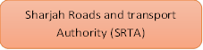

Director General and Chairman of the Board of Directors

internal audit

Traffic & Roads Est
Transportation Foundation
Railway Corporation
Institutional Support Services
Services of technical support of enterprises

control room



Fig.1:Describe the organization structure of SRTA
Problem description:

In Wasit street near Al Qasimi Hospital in Sharjah fixed timing traffic signal lights are uesd. Vehicle density varies from time to time, from area to area. There are peaks during 3 specific times of the day. The first peak accrues in the morning which starts from 6:30 AM to 9:00 AM. While the second peak happens during noon time which starts from 12:30 PM to 3:00 PM. Finally the third peak accrues during evening time which starts from 5:30 PM to 8:30 PM. Regarding to the number of vehicles, it totally depends on the road and area that vehicles pass by. As shown table.1a and fig.1b block diagram for current traffic system.
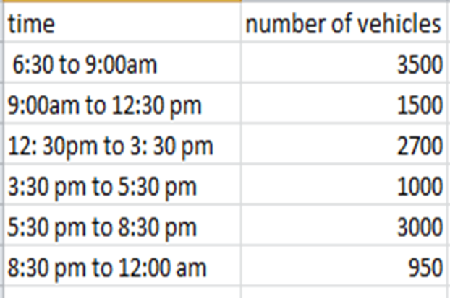

Table.1a
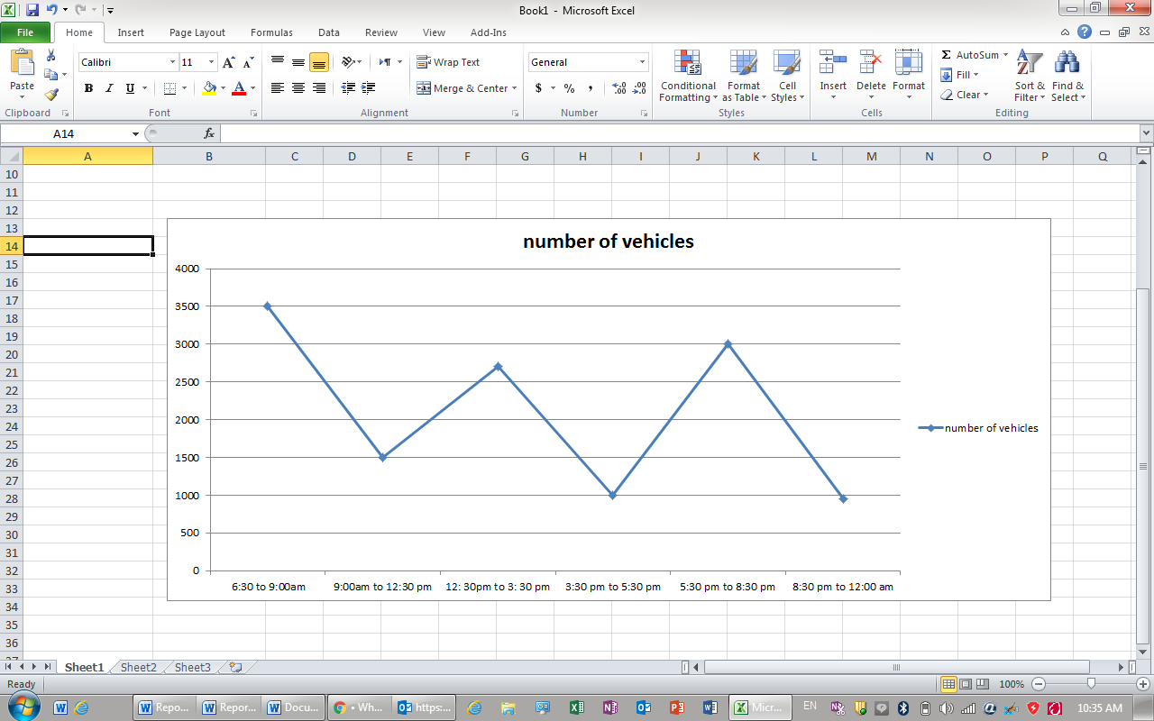

Fig.1b

The problem is centered around fixed timing traffic signal lights. Which means the signal is red or green for a specified time for each side of street irrespective of vehicles. For example, as table3a, fig.3b shown, there are 4 sides of wasit square and each side of them has a specific time. In side1, traffic signal which is 40 seconds and it is fixed. And in side2, there is a specific time traffic signal also which is 35 seconds and it is fixed too, In side3 , 55 seconds and in side4 there are 45 seconds. This means if there is traffic of 20 seconds only in side1 But, it will give whole 40 seconds which means it wastes 20 seconds which can reduce the traffic in other sides. So, in this mode, it needs to have accurate accuracy so that we can assign exact timing in each side.

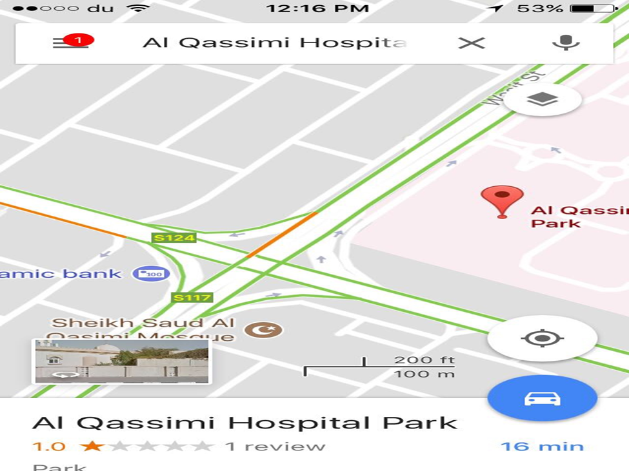
 | branch’s |  | The specified time
 | Branch 1 |  | 40 seconds
 | Branch 2 |  | 35 seconds
 | Branch 3 |  | 55 seconds
 | Branch 4 |  | 45 seconds

Table.3a Fig.3b

This problem occurs when the congestion intensity is different in each side. So, one of that side is free of vehicles or there are a few of them and the signal light is green. On other hand, the street is crowded and the signal light is red. Which means they are disadvantageous when the signal timing of an intersection would benefit from being adapted to the dominant flows changing over the time of the day.

In a traffic signal without sensors ‘’ fixed traffic light’’ , we do not have sensors at site or faulty may be because of loose terminations or may be because of damage or may be improper configuration. It is operation is based on first come first serve which means when the vehicle hits the loop it gives information to detector card then from detector card to central processing unit ‘’CPU’’. After that central processing units checks which comes first and accordingly sends signal to that side and gives green to that side and other side will be red for that period.

Problem boundaries and impacts:
The boundaries of the problem will be the traffic lights signals and the sensors. The impact will be the traffic havoc along Wassit street and it may cause car accidents in the sounded areas.

Solution criteria and limitations:

To solve any problem, it must be taken in consideration all the limitations that may hinder the work later.

This part will discuss the specifications of the current method which is using traffic light signals without sensors, the specifications of the solution and the resources of the solution.

Specifications of the current method |  | Description
Sensitivity |  | low
Reliability |  | low
Complexity |  | simple
\

The table below will illustrate the specifications and the resources of the solution
Specifications |  | Discerption
Cost |  | The maximum budget for SRTA to pay is 80,000 DHS.
Time of the problem table |  | SRTA wants the system to be developed by a period that does not exceed two months.
Sensitivity |  | Sensitivity will be high because the solution will have sensors.
Reliability |  | It will be very high to avoid any risk in the system.
Complexity |  | Based on the company demand the system must be easy to be installed.

Resources | Description
Equipment | Electronic labs, workshops, power supply, drill, Excavators, laptop.
Tools | Screw driver, spanners, players, cutters, bolts, pros kit tools bag, pipes.

In the implementation phase the problem require a specific criteria which is the help of police men and the municipality

Skills (Human Resources)
Activity | SRTA | Engineer  (instrumentation engineer) | Technician  (civil engineer ) | Electrician | labours | The team (Aysha ,Roqaya and Shaima)
Approve | R | S
Test |  | R | S | S |  | S
Install | R | S | S | S | S
` |  |  |  |  |  | R:responsible  S:support

5- Time-based plan for researching problem solutions:

The next step for the following report is to do research for problem solution. The project will take 5 weeks and 3 days to be completed; it will start from 25th September 2017 to 5th November 2017. Table (1) contains the activities with the specific period for each one to be as a plan for the next phase.

ID | Brief description | Duration | predecessor | Name of student
A | Brainstorming to find ideas. | 1 | - | Aysha  Shaima  Roqaya
B | Identify the proposed systems | 3 | A | Aysha
C | Literatures survey | 3 | B | Roqaya
D | Explain how each solution operates. | 3 | C | Shaima
E | Show the advantages and disadvantages of each solution. | 5 | D | Aysha
F | Discuss the idea of each solution and what it needs. | 6 | E | Shaima
G | Evaluate the data by using decision making techniques. | 7 | F | Roqaya
H | Select the best solution | 2 | G | Roqaya

Table (1)

The Gantt chart is a type of bar chart that illustrates a project schedule. Its shows the start and the finish dates of the project as shown in fig.5.

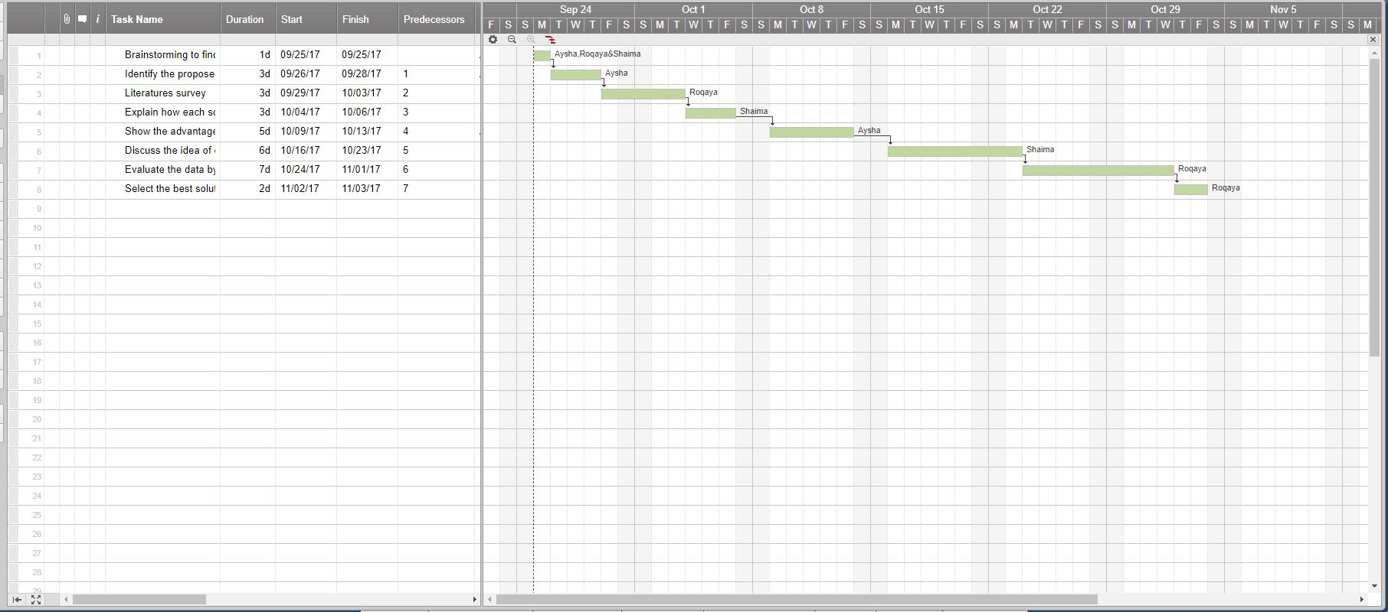

Fig.5 Gantt Chart

^{Reference}

[1] | "Sharjah overhauls transport services," sharjahupdate, 29 September 2015. [Online]. Available: http://www.sharjahupdate.com/2015/09/sharjah-overhauls-transport-services/.

